Use this reference to create a new Program of Study.

To create a program of study, you must complete four steps:
STEP 1: Identify the standard start date of the intended first academic period of the new program of study
STEP 2: Locate an existing program of study to use as a template
STEP 3: Create the new program of study
STEP 4: Create Reference ID Value

Before you begin, you will need:
- Institution Code: Each program of study needs a unique institution code. See Institutional Research, Registrar, and/or IT to request a new code or to communicate the addition of a new code.
Creating a new program of study will appear throughout Workday. Before creating a new program of study discuss all changes with all impacted departments.

Table of Contents:
Ctrl+click to jump to page

STEP 1 – Identify the standard start date of the intended first academic period of the new program of study 2
STEP 2 – Locate an existing program of study to use as a template 2
STEP 3 – Create new program of study 5
STEP 4 – Create Reference ID Value 7

STEP 1 – Identify the standard start date of the intended first academic period of the new program of study

- Use the search bar to locate the Academic Period Dates by Academic Calendar – Standard Start and End Date report.
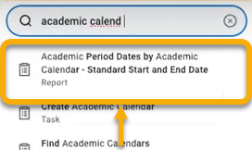

- Identify the term that the new program of study will start, or come into effect. Take note of the date in the corresponding Standard Start Date column. Do not use the Start Date (start of classes).
You will use the Standard Start Date later in the process.
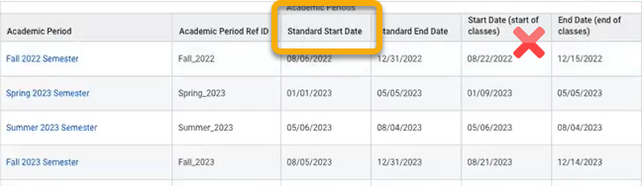

STEP 2 – Locate an existing program of study to use as a template

- In the search bar, type “Find program of study def”. The field will automatically populate. Select the Find Program of Study Definitions report.
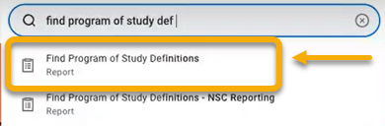

- The Find Program of Study Definitions window will open. Leave fields blank and click “OK”.


- This report displays existing programs of study. You will select a program of study to use as a template in which to build your new program of study. This ensures consistency.
The best program of study template will be one that has the same anticipated Owning Academic Unit, Academic Level and Program Type as the new program of study.
Note: If you do not know the academic level or program type, reach out to a representative of the Owning Academic Unit for more information. This could be an academic department, for example.
Once a program of study is selected, right-click and open the program of study in a new window.
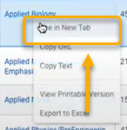

- The selected program of study details will display in the Overview tab.

Click the “Version History” tab.
The Version History tab displays the fields in the same format, side-by-side, as seen in the new program of study. You will copy these details to create your new program of study.
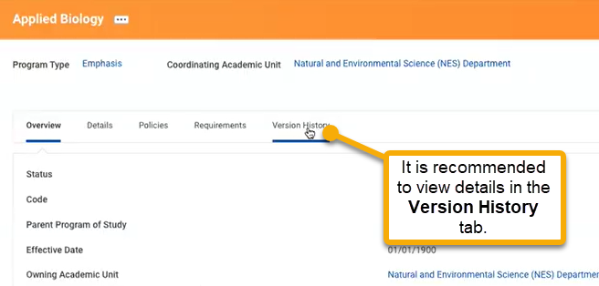

- Click “Edit” to view details.
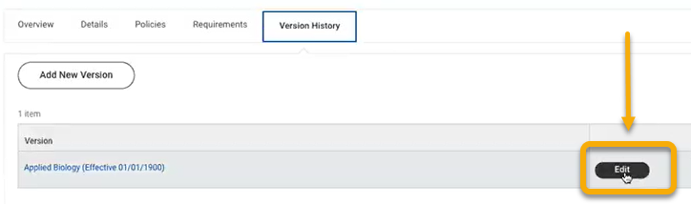

-  DO NOT CHANGE any information on this page. Simply view as a reference.
 Be sure you are in Sandbox. Here is an example of a portion of the Edit Program of
Study Version page.

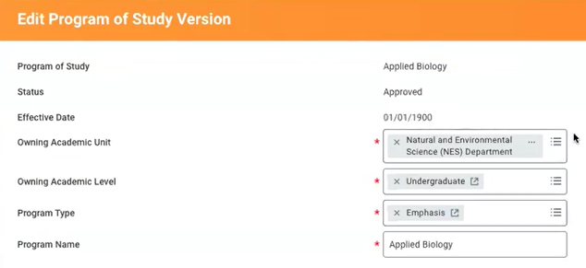

Now, you are ready to copy this information to create a new program of study. While leaving this page open, open a new window and continue in the guide.

STEP 3 – Create new program of study

- In a new window, open Workday Student and type “Create program of study” in the search bar. The field will automatically populate. Select the Create Program of Study” task.

- The Create Program of Study window will appear with four fields: Effective Date, Owning Academic Unit, Owning Academic Level, and Program of Study Type.

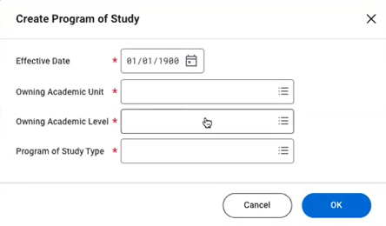

- In the Effective Date, change date to “01/01/1900”.

- For the remaining three fields, reference the Edit Program of Study Version page, copying the corresponding information for Owning Academic Unit, Owning Academic Level, and Program of Study Type.

To do this, you may re-size the Edit Program of Study Version page, so that you can see both pages side-by-side.

- When finished, click “OK”.


- The Create Program of Study window will appear. Place this window side-by-side to the Edit Program of Study Version page. The fields will mirror each other.
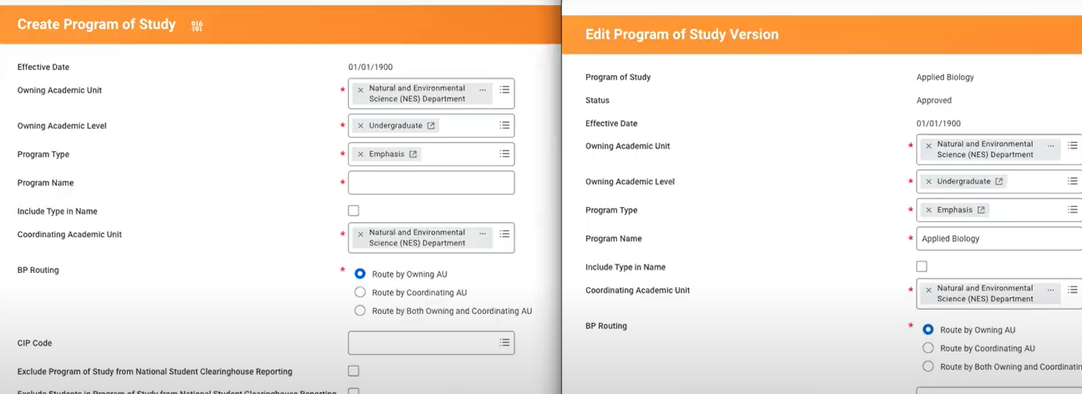

- Proceed through the Create Program of Study window, completing required fields by referencing the Edit Program of Study Version page.

- When finished, locate the First Entry Date field. In this field, input the Standard Start Date found in the STEP 1.
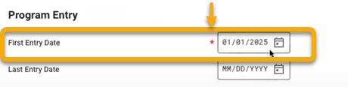

- In the Program Duration fields, match to the fields in the template.
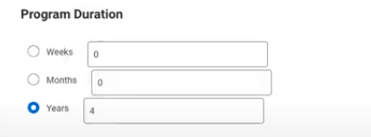

- Leave all other unrequired fields blank.

- Before proceeding, take a pause. Review all fields and compare to the template to check your work. Check for typos and all other details. Do not rush.

- When satisfied, click “Submit”.

STEP 4 – Create Reference ID Value

- From the search bar, locate the Find Program of Study Definitions report.
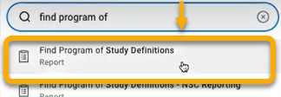

- In the Find Program of Study Definitions window, click “OK”. Do not complete any fields.



- Locate the newly added program of study. If found, the process was completed correctly.

- Click the related actions button next to the new program of study.

- Click “Integration IDs”. Click “Edit Reference ID”.

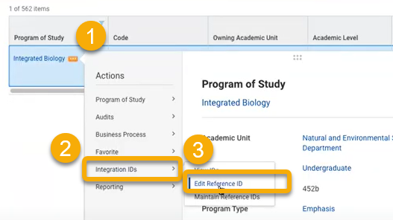

- In the Edit Reference ID window, locate the Reference ID Value field. Replace the Workday-generated text in this field with the Institutional Code used in the initial creation of the new program of study. Note: This can be found in the Find Program of Study Definitions report.
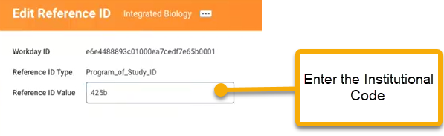

- Click “OK”.

- Click “Done”. Congratulations!

